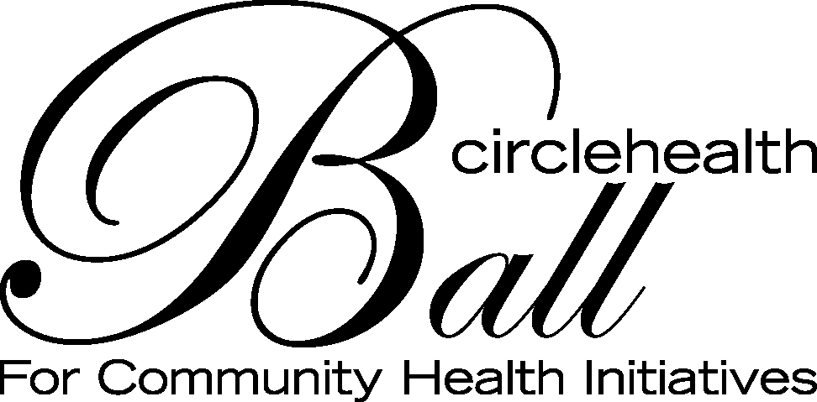

CIRCLE HEALTH BALL FOR COMMUNITY HEALTH INITIATIVES
2017 COMMUNITY HEALTH INITIATIVES GRANT
REQUEST FOR PROPOSAL

2017 Community Health Initiatives Grant:
Circle Health is proud to offer grants for the spring of 2017 as part of the Ball for Community Health Initiatives. In order to help support the growing need for community health programs and support, Circle Health developed the annual event to raise awareness and funds for community outreach and education. The purpose of this RFP is to increase the overall health and wellbeing in the greater Lowell community and surrounding towns.

Grants for 2017 will be awarded around mental health. This priority area was established after review of the Greater Lowell Community Needs Assessment.

Within this priority area, there is a focus on the goal of creating a community that has a shared and respectful understanding of mental health that keeps mental health on an equal level with physical health. Other goals and objectives include, but are not limited to:
  - Increasing access and linkages to mental health services (care coordination)
  - Increasing knowledge and awareness among the community about mental health to help decrease the stigma associated with it.
  - Increase the number of providers from various communities that work in mental health to include different language capacity and cultural sensitivities.
  - Encourage/engage students to pursue careers in the mental health field.

For additional information on the 2016 Greater Lowell Community Needs assessment, please visit: www.lowellgeneral.org/chna

Grant awards cannot be used to fund capital or overhead expenses. Non-profit organizations or public entities (such as municipalities, schools, health institutions and services) are eligible to apply. Priority will be given to agencies whose service area is in the communities of Billerica, Chelmsford, Dracut, Dunstable, Lowell, Tewksbury, Tyngsboro, or Westford. Preference will be given to projects that serve low-income, vulnerable, and/or at-risk communities. Collaborative efforts are also encouraged.

Award Amount and Eligibility:
Grants ranging from $1,000-$10,000 each will be awarded at the discretion of the review committee. Awards will not be given to individuals or be used for scholarships.

Organizations that were funded in 2016 are eligible to apply for funding in 2017 for new programs only, and must have complied with the terms set forth in 2016 including the submission of a progress report, summary report and participate in the video for the 2017 Ball.

Award Criteria:

Completed applications will be judged on the following criteria:
- Well-designed project that fits into the priority area
- Clear explanation of the project and demonstration of what effect this project will have on increasing services provided to target population
- Clear, demonstrated health need supported by available data
- Clear, measurable goals and objectives
- Realistic timeline for implementation of project
- Demonstrated plan for evaluation to measure program success
- Explanation of expected outcomes
- Demonstrated collaborative efforts with other community organizations that are part of the system of care for the stated target population
- Plan for sustainability of funded program in future years (if applicable)
- Detailed budget

Application Process:
Applicants must complete the following application (cover sheet and narrative with budget) and may apply for up to $10,000 per project. Funds must be used to advance the objectives of the program and will be reviewed accordingly. An organization may only submit one proposal as the lead organization, but can be listed as a collaborator on others.

In addition to the cover sheet, narrative page, and budget, an application will only be considered complete when it includes the following supporting documents (where appropriate):
- Updated list of your Board of Directors
- Federal tax exempt letter including tax identification number
- Most recent 990 filing

A grant review committee will review and score all applications based upon the previously stated award criteria.

Deadlines:
- The RFP will be released on Monday, November 28, 2016 and all grant applications must be received no later than 5:00pm on Friday, December 30, 2016. PLEASE NOTE: No extensions or exceptions will be allowed on the application deadlines. Applications can be sent by email to Amy.Werner@lowellgeneral.org or by mailing a hard copy to:
Amy Werner
Director of Philanthropy
Lowell General Hospital
295 Varnum Avenue
Lowell, MA 01854

- All questions or concerns in regard to this RFP may be directed to Amy Werner at 978-788-7378 or at Amy.Werner@lowellgeneral.org until 12:00 pm on Thursday, December 29, 2016.

- Winning grant recipients will be notified by January 13, 2017 via phone or email.

Requirements of Recipient Organizations:
Successful applicants will be expected to:

- Submit a progress report six months after receiving the award and a summary report within three months following the completion of the funded project.

- Participate in a video project for the 2017 and 2018 Circle Health Ball for Community Health Initiatives.

- Send a representative to the Ball at the Westin Boston Waterfront on March 4, 2017. (optional)

CIRCLE HEALTH BALL FOR COMMUNITY HEALTH INITIATIVES
2017 COMMUNITY HEALTH INITIATIVES GRANT
APPLICATION FORM

Please include the Application Form as the Cover Page. Complete all of the following information.

Project Title: ________________________________________________________________
Name of Contact Person: _______________________________________________________
Full Legal Name of Organization/Group: __________________________________________
Alternate Name(s) of Organization/Group: _________________________________________
Address: ____________________________________________________________________
City: ______________________________ State: ____________ Zip Code: _________
Phone Number: ___________________________ Fax Number: _________________________
Email Address: _______________________________________________________________
Amount of Funding Requested: $ ________________________________________________

NOTE: If your organization has a fiscal agent/conduit other than the applicant named above, please complete the following information.

Name of Fiscal Contact Person: ___________________________________________________

Name of Fiscal Agent/Conduit: ___________________________________________________

Address: _____________________________________________________________________
City: ______________________________ State: ____________ Zip Code: _________
Phone Number: ______________________________ Fax Number: ______________________

NARRATIVE PAGE

Please answer the following questions about your project. Application, including cover sheet, narrative, and budget must not exceed six pages.

1. Provide a brief overview of your organization’s mission, history of the organization, and details of your organizational structure. Describe who you are, why you exist, and what you do. Describe your history to date, including the age of your organization and key accomplishments or areas of significant work in the community. Describe your size, structure, and who is involved with the organization in no more than one page.

2. Provide a brief overview of the proposed project including: a statement of the community need based on available data, the target population, estimated number of people that will be impacted, overall purpose of the project, how this project will increase or improve services in the Greater Lowell area, specific barriers your project may address, and expected outcomes in no more than one page.

3. Outline specific project goals and objectives and include a timeline for each of them. Identify your goals by number. Please note that objectives must be measurable. Suggested format for objectives: SMART (specific, measurable, attainable, realistic, and time-framed).

4. Describe the evaluation process you will use to determine whether the project meets the stated goals and objectives.

5. Provide a brief plan for how you intend to sustain this work beyond current funding. Programs that fund staff time without demonstration of how services will continue beyond the duration of this grant period will not be favored.

6. Provide an itemized budget for the total amount of funding you are requesting. Include a total budget for this project, as well as any additional matching/contributing funds and in-kind services. No funds may be used for general administrative or overhead costs.

