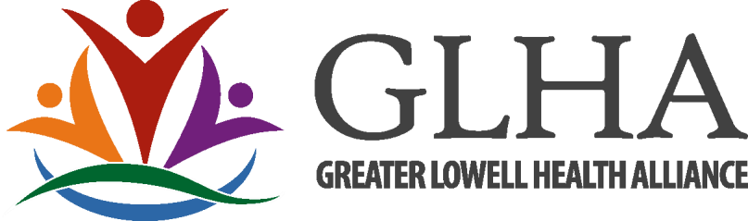
GREATER LOWELL HEALTH ALLIANCE
FY 2026 COMMUNITY HEALTH INITIATIVES MINI-GRANT
REQUEST FOR PROPOSALS

Community Health Initiatives Mini-Grants
The Greater Lowell Health Alliance of the Community Health Network Area 10 (GLHA of CHNA 10) is comprised of healthcare providers, business leaders, educators, civic and community leaders with a common goal to help the Greater Lowell community identify and address its health and wellness priorities. The Greater Lowell Health Alliance of CHNA 10 is proud to offer mini grants throughout 2026 to support programs and services that improve the overall health of the Greater Lowell community. The purpose of these mini-grants is to provide funding to address the health disparities listed within the 2025 Community Health Needs Assessment.

Section 1: Identifying the Need
In partnership with Lowell General Hospital and the University of Massachusetts Lowell the Greater Lowell Health Alliance conducted a community health needs assessment to identify the unmet medical and public health needs within the Greater Lowell Community.

Grants will be awarded around the following health priorities. These funds are designed to support the infrastructure of the task force work. (Examples: surveys, data collection, translations, policy work, networking materials, etc.)

Please check all that apply:
 Poverty
 Mental Health
 Chronic Disease
 Nutrition/Food Access
 Substance Use Disorder
 Older Adults
 Youth & Adolescents
 People with disabilities
 Pregnant/Postpartum people
 Immigrants/refugees
 LGBTQ+

Grant awards cannot be used to fund capital or overhead expenses. Non-profit organizations or public entities (such as municipalities, schools, health institutions and services) are eligible to apply. Priority will be given to projects and proposals developed through the GLHA Task Forces and Subcommittees;
- Behavioral Health Task Force
- Substance Use and Prevention Task Force
- Health Equity Task Force / Older Adult Subcommittee
- Maternal/Child Health Task Force
- Wellness & Chronic Disease Task Force

And whose service area is within the CHNA 10 designated by the Department of Public Health. Those communities include Billerica, Chelmsford, Dracut, Dunstable, Lowell, Tewksbury, Tyngsboro, and Westford. Towns outside the CHNA 10 service area may serve as partners on grants. Organizations not currently participating in above task forces are encouraged to apply and welcome to join the task forces. Preference will be given to projects that serve low-income, vulnerable, minority and/or at-risk communities. (*Additional task forces may be established to meet priority areas if not currently being met.)

Award Amount and Eligibility
A total of ten thousand dollars will be allocated to support efforts of these critical health issues. Grants will be awarded at the discretion of the GLHA Steering Committee. Awards will not be given to individuals or be used for scholarships.

Criteria - $10,000 will be allocated for mini-grants in FY2026; Awards ranging up to $1,500.

Award Criteria
Completed applications will be judged on the following criteria:
- Project fits into the health priority areas defined in the 2025 Community Health Needs Assessment.
- Incorporates a plan to meet National CLAS Standards
- Clear explanation of the proposed project and demonstration of the impact the project will have on target audience.
- Clear, demonstrated health need supported by available data
- Clear, measurable goals and objectives
- Realistic timeline for implementation of project
- Explanation of expected outcomes
- Demonstrated plan for evaluation to measure program success
- Demonstrated collaborative efforts with other community organizations that are part of the system of care for the stated target population
- Plan for sustainability of funded program in future years (if applicable*)
- ➢ Appropriate budget

(*“Applicable” defined: If this project is part of an effort your organization plans to continue beyond the grant cycle, we’d like to know how you intend to continue the project.)

Application Process
Applicants must complete the following application and may apply for up to $1,500. Funds must be used to advance the objectives of the proposed program and will be reviewed accordingly. An organization may only submit one proposal as the lead organization each cycle/year, but can be listed as a collaborator on others.

Applications can be sent by email (preferred method) to amanda.clermont@greaterlowellhealthalliance.org or by mailing a hard copy to:

Amanda Clermont
Greater Lowell Health Alliance
295 Varnum Ave, Lowell, MA 01854

All questions or concerns in regard to this RFP may be directed to Amanda Clermont at 978-934-8531 or at amanda.clermont@greaterlowellhealthalliance.org

Requirements of Recipient Organizations Successful applicants will be expected to:
- Assign a representative to participate in the GLHA task force aligned with their project, if they have not already done so.
- Submit a summary report within three months following the completion of the funded project.
- Money is to be spent out in a 12-month period or returned to GLHA.

GREATER LOWELL HEALTH ALLIANCE
2026 COMMUNITY HEALTH INITIATIVES MINI GRANT APPLICATION FORM

Please include the Application Form as the Cover Page. Complete all of the following information.

Project Title: ___________________________________________________________________
Name of Contact Person: _________________________________________________________
Full Legal Name of Organization/Group: ____________________________________________
Alternate Name(s) of Organization/Group: ___________________________________________
Address: ______________________________________________________________________
City: _______________________________ State: ____________ Zip Code: _____________
Phone Number: ___________________________________Fax Number: ____________________
Email Address: _________________________________________________________________
Amount of Funding Requested: $ ________________
Health Priority/Task Force Lead: _____________________________________________

CHNA disparity addressed: ___________________________________________________________

NOTE: If your organization has a fiscal agent/conduit other than the applicant named above, please complete the following information.

Name of Fiscal Contact Person: ______________________________________________________
Name of Fiscal Agent/Conduit: ______________________________________________________
Address: ________________________________________________________________________
City: ___________________________________ State: ___________ Zip Code: _____________
Phone Number: __________________________ Fax Number: ______________________

GLHA Task Force Affiliation:

Target community:

Goals of the Project:

Project Description/Objective:

Timeline

Project Evaluation

Project Budget

GLHA Steering Committee Approval: Yes / No

