**November 17, 2023**

**Subject: Join "Together for the Holidays" - A 24-Hour Zoom Space for Support and Connection**

Dear Partner Organization,

I hope this letter finds you well. As we approach the holiday season, the Greater Lowell Health Alliance (GLHA) Substance Use Prevention and Behavioral Health Task Forces are combining forces to launch a special initiative called "Together for the Holidays." In the spirit of fostering support, connection, and mental well-being, we are reaching out to partner organizations like yours to join us in this meaningful endeavor.

The "Together for the Holidays" event aims to provide a 24-hour Zoom space for individuals who may be experiencing feelings of depression, trauma, or simply seeking connection during the holiday season. Our goal is to offer a supportive and inclusive environment where people can engage in various activities that promote well-being and provide a sense of community.

We are reaching out to invite your organization to participate by hosting a one-hour programming slot during this event. The programming can be diverse and tailored to your strengths and interests. Whether it's leading a yoga session, hosting a movie night, offering a space for open conversations, or organizing a more structured activity like an "art therapy hour," your contribution can make a significant impact on the well-being of those in need.

We believe that by coming together as a community, we can create a positive and uplifting experience for individuals who may be facing challenges during the holiday season. Your participation in "Together for the Holidays" will not only benefit those seeking support but will also reinforce the sense of unity within the Greater Lowell community.

If your organization is interested in being a part of this initiative, please let us know your preferred time slot and the type of programming you would like to offer. People can sign up at: <https://docs.google.com/spreadsheets/d/1LHu0WcLUj4g2YOUYEsjxZK6Cpof3AWO7W5d9Uvn4jRY/edit?usp=sharing>

Together, we can make a difference and spread warmth during the holidays. Thank you for considering our invitation, and we look forward to the possibility of collaborating with your organization to make "Together for the Holidays" a meaningful and successful event.

Please feel free to contact us at [kdentremont@greaterlowellhealthalliance.org](mailto:kdentremont@greaterlowellhealthalliance.org) for further details or to express your interest.

Wishing you a joyful holiday season.

Warm regards,

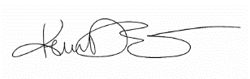 

Kerrie D’Entremont  
Executive Director, Greater Lowell Health Alliance   
Mike Hall, Casa Esperanza  
Chair, GLHA Substance Use Prevention Task Force

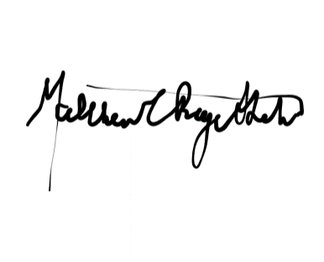

Matthew Page-Shelton, Front Line Services   
Co-Chair, GLHA Behavioral Health   
Task Force



Daniela Johnson, Vinfen  
Co-Chair, GLHA Behavioral Health Task Force